+

COMP390

2025/26

A Comparative Evaluation of U-Net Variants for Medical Image Segmentation on the CathAction Dataset

Kaijie Yang
201690423

BSc Computer Science

SCHOOL OF
COMPUTER SCIENCE & INFORMATICS

University of Liverpool
L69 3DR

Acknowledgements:
I would like to express my sincere gratitude to my supervisors, Dr Anh Nguyen and Dr Yi Dong, for their valuable guidance, support, and constructive feedback throughout this project. Their advice helped me develop a clearer understanding of the research topic and improve the quality of this dissertation.

I would also like to give special thanks to Dr Anh Nguyen for providing valuable reference papers and access to the CathAction dataset, which were essential for the development of this research.

I sincerely appreciate their patience, encouragement, and valuable comments during each stage of the project. Their supervision has been essential in helping me refine my research direction, strengthen my analysis, and complete this dissertation successfully.



COMP390

2025/26

A Comparative Evaluation of U-Net Variants for Medical Image Segmentation on the CathAction Dataset

BSc Computer Science

SCHOOL OF
COMPUTER SCIENCE & INFORMATICS

University of Liverpool
L69 3DR

Abstract:
This study presents a comparative evaluation of the performance of four U-Net variants, namely U-Net, R2U-Net, Attention U-Net, and Attention R2U-Net, around the segmentation task of intravascular interventional X-ray images in the CathAction dataset. The research task is defined as a three-class pixel-level semantic segmentation, where the object categories include background, catheter, and guidewire. In the experiment, the X-ray images of artificial silicone vascular model are used as the training and validation data, and the four models are trained under the uniform data partition, input resolution, optimizer, loss function and evaluation metric. In the experiment, a hybrid loss function composed of Dice loss and focal loss is used to alleviate the class imbalance problem caused by the high proportion of background pixels. The results show that U-Net obtains the highest validation set mDice, which is 0.6812, and Attention U-Net's performance is close to it, mDice is 0.6777. In contrast, the validation performance of R2U-Net and Attention R2U-Net is lower. The results show that in the current CathAction silicone vascular phantom X-ray segmentation task, the more complex cyclic residual structure does not bring the expected performance improvement, and the more stable encoder-decoder structure and attention mechanism are more suitable for this task. Future research can further introduce Transformer-based segmentation models, CNN-Transformer hybrid networks and other models to improve the segmentation effect of thin and low contrast objects such as guidewires and catheters.

Key words: CathAction; Medical image segmentation; U-Net; Attention U-Net; R2U-Net; Guidewire catheter segmentation; Dice score

Statement of Ethical Compliance
Category: No more than B
Participant Category: 0
I confirm that I have read the ethical guidelines and will follow them during this project.

Introduction & Background

2.1 Project Overview
Endovascular interventional surgery relies heavily on the precise coordination of guidewires and catheters. Surgical risks may also arise when contact or collision between the instrument tip and the vessel wall is not identified and addressed in time [1]. Using current technologies accurately to identify and separate these devices using phantom-based endovascular X-ray images is difficult. Phantom-based endovascular X-ray images present problems such as low contrast, motion blur, and instrument overlap [2]. Further-more, privacy restrictions on intraoperative images cause large-scale machine learning training to be a bottleneck. This project evaluates four U-Net-based segmentation models for catheter and guidewire segmentation using the CathAction dataset. The main objective is to compare whether recurrent residual blocks and attention gates improve foreground segmentation performance over a U-Net baseline under the same preprocessing, training, and evaluation settings. This study conducts deep learning research on pixel-level separation of guidewires and catheters, developing a visual recognition model with potential value for image-guided endovascular intervention.
Aim：
- This study will use phantom-based endovascular X-ray images from the CathAction dataset to train U-Net-based models, enabling them to automatically analyse guidewires and catheters and stably segment their shapes and locations in images.
- This study uses the human silicone phantom subset of the CathAction dataset to train and validate four U-Net-based segmentation models. The objective is to compare their segmentation performance under a fixed experimental setting.

2.2 Dataset (CathAction)
CathAction is a large-scale X-ray video dataset designed for endovascular intervention understanding (Figure 1). This dataset is mainly used for visual analysis of catheters and guidewires during interventional procedures, including catheter/guidewire segmentation, collision detection, action recognition, and action prediction [3]. CathAction contains approximately 500,000 annotated frames for catheterization understanding and collision detection tasks, as well as around 25,000 ground-truth masks in uint8 format for catheter and guidewire segmentation.

The CathAction data were collected from human silicone vascular phantoms in an operating-room environment. Therefore, it is not a conventional natural image dataset, but a medical imaging dataset specifically designed around realistic interventional scenarios. The dataset is intended to support research on robot-assisted endovascular intervention, including autonomous catheter manipulation, data generation, and medical training. In addition, it also includes a subset of animal experimental images, which can be used to test the performance of trained models.
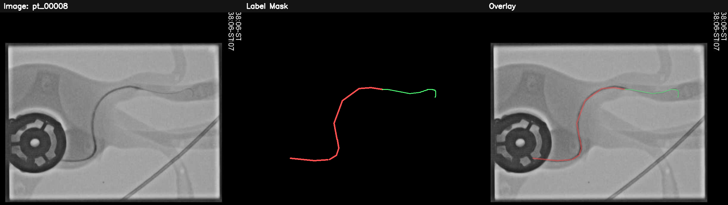
Figure 1. CathAction image example.
For the ground-truth masks subset of the dataset, the X-ray images are provided in .png format, while the corresponding mask annotations are provided in .npy format. This format is suitable for training medical image segmentation models such as U-Net, Attention U-Net, R2U-Net, TransUNet, and Swin-U-Net. The segmentation data structure provided by the CathAction dataset includes train/images, train/labels, test/images, and test/labels (Table 1). The X-ray images have varying resolutions, ranging from 512 × 512 to 1500 × 1500.
Table 1. CathAction dataset segmentation data composition.
Name | Number of images | Number of two-class masks | Number of three-class masks
Animal_test | 1,006 | 475 | 531
Animal_train | 4,021 | 1904 | 2117
Phantom_test | 3,685 | 1520 | 2165
Phantom_train | 14,737 | 5994 | 8743

2.3 Medical Image Segmentation and U-Net
Medical image segmentation is an important task in computer-aided diagnosis and image-guided therapy. Its goal is to distinguish different tissues, organs, lesions, or instrument regions in medical images [4]. Therefore, medical image segmentation tasks place higher demands on the spatial localization and detail recovery capabilities of models. In endovascular interventional surgical images, guidewires and catheters typically appear as slender, low-contrast targets that easily overlap with background structures, making it difficult for traditional image processing methods to reliably complete segmentation tasks [5].

U-Net is one of the most representative deep learning models in medical image segmentation. The U-Net model proposed by Ronneberger, Fischer and Brox adopts an encoder-decoder architecture (U-shaped architecture), where the encoder extracts high-level semantic features by layer-by-layer down sampling, and the decoder gradually recovers the spatial resolution by up sampling [6]. At the same time, U-Net uses skip connections to transfer the shallow spatial features in the encoder to the decoder, so as to improve the ability of boundary localization while preserving context information. The model consists of a contracting path for context extraction and a symmetric expanding path for precise localization, this architecture is suitable for segmenting low-contrast and slender structures [6].

Therefore, U-Net is very suitable as the base model for this study. For the guidewire and catheter segmentation tasks in the CathAction dataset, U-Net can exploit both deep image information and shallow spatial details. However, the standard U-Net also has some limitations, its ability to suppress irrelevant background clutter is limited, and in the case of small targets and serious class imbalance. Under severe class imbalance, the model may become biased towards the dominant background class, resulting in missed catheter or guidewire pixels. [7]. At the same time, objects such as guidewires and catheters usually occupy only a small number of pixels in X-ray images, and relying only on the ordinary U-Net structure may not be enough to fully capture these small foreground structures. Therefore, this study introduces improved models such as Attention U-Net and R2U-Net to try to improve and compare [8][9].

2.4 Attention Mechanisms in Medical Segmentation
The main role of attention mechanism in model construction is to help the model improve the attention of related targets and reduce the interference of irrelevant background regions on the prediction results [8]. Medical images usually contain a lot of background tissues, noise and low-contrast structures. In this case, if the model assigns the same weight to all spatial regions, it is easy to lead to blurred boundaries, missed target detection or false background detection. The attention mechanism enables the model to make more selective use of feature information by learning the spatial or channel weights.

Attention U-Net is an important improved version of U-Net. Attention gate structure, which is used to automatically filter the features passed by the encoder to the decoder during the skip connection stage [8]. The skip connection in ordinary U-net transmits all features unconditionally, while the attention mechanism filters these features through attention gates before passing them to the decoder. The model will automatically focus on target structures of different shapes and sizes while suppressing task-irrelevant regions, and no additional external localization module is required [10].

2.5 Recurrent Residual U-Net
R2U-Net is an improved model combining recurrent convolution and residual learning on the basis of U-Net. The core idea is to replace the ordinary convolutional block with the recurrent residual convolutional block, so that the model can extract and accumulate features multiple times at the same level. R2U-Net combines the advantages of U-Net, Residual Network and Recurrent Convolutional Neural Network, where residual units help improve the training of deeper networks. The recurrent residual convolutional layers can improve the feature representation ability in segmentation tasks through feature accumulation [9].

The potential advantage of R2U-Net over the standard U-Net is its ability to enhance the local feature modeling capability without relying exclusively on increasing the network depth. R2U-Net enhances the feature extraction ability by using recurrent residual convolutional units to replace the convolutional modules in ordinary U-Net [11]. Among them, recurrent convolution refines features on the same spatial scale for multiple iterations, and residual learning introduces identity shortcut inside each module, so that the model does not have to directly learn the complete mapping. Instead, it learns the residual change between the input feature and the target feature. This helps to improve gradient propagation and improve training stability for deeper recurrent convolutional units [9].

However, R2U-Net does not necessarily consistently outperform standard U-Net in all tasks. Since recurrent residual block increases the model complexity, the learning rate, data volume, resolution and regularization strategy in training are more sensitive. At the same time, the model pays too much attention to local texture, which may also cause the problem of mis-segmentation of background linear structures.

Model Implementation & Project Structure
This project consists of four main model training files, plus a data preprocessing program, a visual model and a prediction front-end page. This section mainly explains the detailed configuration and configuration logic of each model training algorithm, and briefly introduces another program structure. For a detailed explanation of the algorithm module's implementation, please refer to the code file.

3.1 Data preprocessing
The main purpose of the data preprocessor script, datacheck.py, is to perform a basic quality control on the segmentation dataset before model training or testing. For medical image segmentation tasks, the consistency between the image and the annotation mask is very important. If the image and mask filenames do not match correctly, or the class encoding of the mask does not meet the requirements of the model, subsequent training may have problems such as misaligned labels, wrong number of classes, abnormal loss calculation, or distorted evaluation metrics.
Here, this script performs the following checks on the dataset:
1. Check that the number of images and masks match.
2. Check for missing masks or images;
3. Check the data type of the mask, e.g. uint8, float32, etc.
4. Check that the spatial resolution of the mask is consistent;
5. Check what unique pixel values appear in the mask;
6. Count the number of classes in each mask.
7. Determine if masks are likely to be in one-hot or multi-channel format.
As shown in Table 2, the program outputs the number of images and masks, missing-file information, mask data types, mask resolutions, unique class values, and the number of masks containing different class combinations.
Table 2. Example of dataset validation outputs.
Validation item | Output result | Interpretation
Number of images | 3,685 | The dataset contained 3,685 image files.
Number of masks | 3,685 | The number of masks matched the number of images.
Missing masks for images | 0 | No image file was missing its corresponding mask.
Missing images for masks | 0 | No image file was missing its corresponding mask.
Mask data type | uint8 | Masks were stored as integer label maps.
Mask resolution | Multiple resolutions observed | Mask sizes were not uniform before preprocessing
Unique class values | 0,1,2 | The masks used three discrete label values.
Number of unique classes in sampled masks | 3 | The sampled masks contained three class labels.
Masks containing 2 unique label values | 1,520/3,685,41.2% | Number of masks containing two types of label values
Masks containing 3 unique label values | 2,165/3,685,58.8% | Number of masks containing three types of label values
Prior to model training, this study examined the dataset using a data validation script. These steps can detect problems such as missing annotations, inconsistent size, abnormal category values, or one-hot/RGB masks before training, thereby improving the reliability of subsequent U-Net series model training and Dice and IoU evaluation results. At the same time, the number of classifications of different data masks is determined to prepare for the subsequent filtered training process.

3.2 U-Net
In this study, U-Net was first used as a baseline model to evaluate the baseline performance of the traditional encoder-decoder segmentation architecture in CathAction guidewire and catheter segmentation tasks [12]. The program uses the U-Net model implemented in segmentation_models_pytorch and sets the number of input channels to 3 and the number of output categories to 3, corresponding to the background, catheter and guidewire pixels respectively (Figure 2). The image is read from OpenCV and converted to RGB format, while the mask is read from .npy file with {0,1,2} labels and finally converted to long for multi-class semantic segmentation training. This script includes not only the model definition but also the complete experimental workflow, including data loading, data augmentation, loss function design, training, validation, performance evaluation, and best-model checkpoint saving.
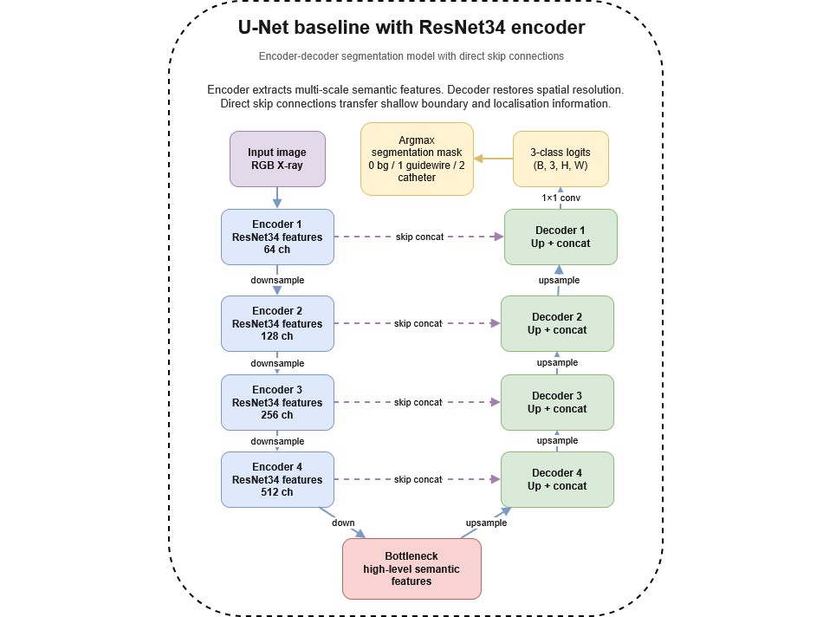
Figure 2. U-net algorithm architecture.

3.2.1 Encoder-Decoder Architecture
The core idea of U-net is the typical encoder-decoder segmentation framework [6]. The encoder progressively downsampled to extract high-level semantic features. The decoder progressively upsamples and recovers the spatial resolution. In the code, the whole structure is composed of smp.Unet(...) Direct instantiation implements pixel-level classification results that output the same scale as the input image.

In the Encoder-Decoder segmentation framework, the Encoder is responsible for gradually reducing the spatial resolution of the image and extracting higher level semantic features. The Decoder is responsible for gradually restoring the image resolution, mapping the abstract features back to the pixel-wise prediction. In this segmentation task, the encoder's role is to understand the overall structure in the X-ray image, such as the direction of the instrument, the background tissue, and the lumen region. The role of decoder is to recover the spatial position of the guidewire and catheter, so that the model can output a segmentation mask with the same size as the input image. In this program, U-Net baseline is not the full traditional U-Net, but calls smp.Unet() [13]. The model input is a three-channel RGB image, and the output is the logits of three categories. Finally, each pixel is assigned to the background, guidewire or catheter category by torch.argmax.

3.2.2 Skip connection
Skip connection is one of the core advantages of U-Net [6].The common encoder-decoder structure will lose some spatial details after multiple down-sampling, and medical image segmentation often requires accurate boundaries. Especially in the CathAction segmentation dataset, guidewires and catheters are elongated structures, and the model may have difficulty recovering their edges and continuous morphology if it only relies on deep semantic features. By introducing skip connection, the model can use deep features to complete category discrimination, and use shallow features to supplement edge and texture details, so as to improve the accuracy of boundary segmentation in the process of model recognition. This is especially important for fine structures in medical images such as catheters, instrument boundaries, and tissue contours.

The Skip connection directly passes the encoder shallow features to the decoder, enabling the decoder to reuse the earlier edge, texture, and position features when restoring the spatial resolution. In this program, skip connections are implemented internally by the segmentation_models_pytorch U-Net architecture. These connections allow low-level spatial features from the encoder to be fused with high-level decoder features, which is important for recovering thin catheter and guidewire boundaries.

3.2.3 ResNet34 encoder
The U-Net baseline in this program uses ResNet34 as the encoder instead of using the ordinary convolutional encoder in the original U-Net. encoder_name="resnet34" is explicitly set. This change significantly improves baseline's feature extraction capabilities. In the CathAction segmentation dataset, the background structure is complex and the contrast between the guidewire and catheter and the surrounding tissue is low, so using ResNet34 encoder can help the model extract stronger edge, texture and local morphological features.

ResNet34 is a convolutional neural network with residual connection. Compared with the ordinary convolutional stack structure, it is easier to train deeper networks and can effectively alleviate the the vanishing-gradient problem [14]. ResNet34 is selected as the encoder of U-Net because its feature extraction ability is stronger than the lightweight shallow backbone and the network depth is moderate. In the U-Net framework, ResNet34 is responsible for extracting multi-scale features layer-by-layer from the input RGB image for the decoder to subsequently restore the resolution and generate the segmentation results. It may improve the convergence stability of the model and the training performance under small sample conditions [15]

3.3 R2U-Net
As shown in Figure 3, the program implements a multi-class medical image segmentation model based on R2U-Net. The classic U-Net encoder-decoder framework introduces self-designed recursive convolution and residual connections. This enhances its feature representation capabilities and improves the effect of multi-scale information fusion [9]. The complete training process consists of data reading, data augmentation, network construction, loss function definition, optimization strategy, validation and evaluation, and best model saving.
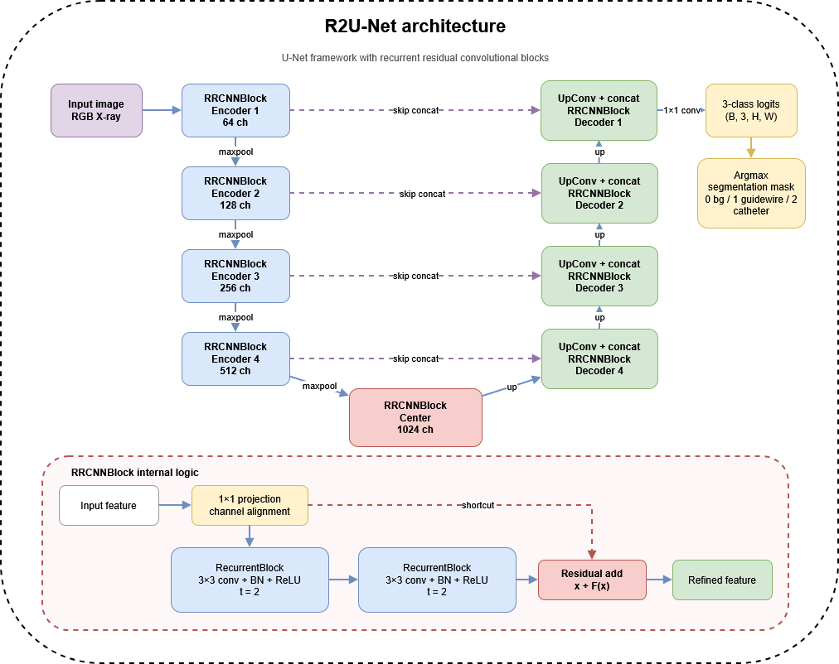
Figure 3. R2U-net algorithm architecture.
Compared with the traditional U-Net, the convolution feature extraction module is redesigned. Specifically, the program constructs the recurrent feature extraction unit through the RecurrentBlock, and then combines the recurrent structure with the residual mapping by using RRCNNBlock, so as to form a stronger local feature modeling ability. The network compresses the spatial resolution and enhances the semantic representation layer by layer at the encoder. The spatial details are recovered layer-by-layer at the decoder, and the shallow features are passed to the corresponding decoding layer through skip connections, so as to achieve fine pixel-wise segmentation prediction [6].

3.3.1 Recurrent block
The definition of recurrent block in this program is given in the RecurrentBlock module. The design idea is to repeatedly refine the input features through multiple convolution iterations of shared parameters within the same layer feature space. Improve representation without significantly increasing the number of parameters [16]. Different from the ordinary convolution block which only performs one forward transformation, the recurrent convolution block uses a recursive update mechanism to make the features at the current time be affected by the original input and the output of the previous step [9][18]. From the feature learning perspective, the role of recurrent block is to repeat refinement of the input features and not significantly increase the same layer of network in the network depth structure. The first convolution can extract the basic local features, and the subsequent convolutions continue to extract features based on the addition of the original input and the previous output. The potential advantage of this is to allow the model to repeatedly focus on edge, texture, and shape information at the same scale.

For code implementation, RecurrentBlock first defines a basic convolution unit consisting of 3×3 convolution, batch normalization, and ReLU activation. During the forward propagation, the module controls the number of cycles through the parameter t=2. In the first iteration, the input feature x is first convolved to obtain the initial response. Subsequently, the same convolution operation is repeatedly applied to x + x1 at each iteration.

For the guidewire and catheter segmentation task of the CathAction dataset, this convolutional structure is well suited for the capture of continuous boundaries of elongated instruments. The image background can easily interfere with guidewires and catheters occupying only a few pixels. Recurrent block can enhance the local response through repeated convolutions, allowing the model to learn these subtle structures more fully.

3.3.2 Residual connection
Based on the RecurrentBlock establishment, the program further constructs RRCNNBlock by residual connection [9]. This module is one of the key components that distinguish R2U-net from ordinary U-Net, and its core idea is to add the input feature map and the cyclic convolution extraction result element-by-element, so as to realize residual learning [14].

Firstly, RRCNNBlock adjusts the input channel to the target dimension by 1×1 convolution. This operation accomplishes both channel alignment and plays the role of linear projection. Then, the program stacks two RecurrentBlock modules to form a recurrent convolutional subnetwork. At the end of forward propagation, the module adds the projected input feature x with the recurrent convolutional output x1 to obtain the final output x + x1.

The residual connection has the following two roles. First of all, it preserves the original representation of the input features, and the model does not need to fully re-learn the output features, but only needs to learn the incremental correction of the input features. Secondly, residual learning can optimize the gradient propagation path in the deep network, reduce the optimization difficulty in the training process, and improve the convergence stability of the network [14]. In the feature module that requires cyclic calculation, the residual connection can avoid the problem of excessive deformation or degradation of information after multiple iterations of convolution.

In the segmentation task of guidewire and catheter, the residual structure not only retains the details in the original image features, but also enhances the expression of the target structure by recurrent convolution. Therefore, compared with the ordinary convolutional block, it is theoretically more suitable for learning the slender guidewire structure with fuzzy edges and low contrast.

3.3.3 Feature accumulation
feature accumulation in the program is mainly reflected in two levels: 1. Progressive accumulation of the same scale features inside the loop block, and 2. Multi-scale feature aggregation across layers in the whole R2U-Net network.

The first level of feature accumulation occurs in the RecurrentBlock. Since x + x1 is used as the new convolution input in each iteration, the subsequent features are always built on the joint effect of the previous round response and the original input, so the model actually completes the accumulation of progressively refined features on the same level. This accumulation process helps the network integrate local texture, edge, and context information more fully.

The feature accumulation at the second level is reflected in the whole encoder-decoder structure. The program extracts feature step by step through five RRCNNblocks at the encoder, and the number of channels is 64, 128, 256, 512, and 1024 in turn. As the network down-sampling proceeds, the space size of the feature map decreases continuously, while the degree of semantic abstraction increases continuously. Then, on the decoder side, the program upsamples the features step by step through UpConv, and uses torch.cat() to concatenate the features of encoder and the upsampled features of decoder, and then fuses them through RRCNN block.

Feature refinement occurs inside each recurrent block because the convolutional operation is repeatedly applied to the combination of the original input and the previous response. In addition, multi-scale feature fusion is achieved through skip connections between encoder and decoder layers. Therefore, R2U-Net combines within-block recurrent refinement with cross-layer feature fusion, rather than relying only on deeper convolutional layers. For the more, the concatenated features are not directly output, but re-input to RRCNNBlock for cyclic residual modeling, which means that the feature fusion will undergo additional recursive refinement and residual enhancement processing, so that the cumulative features can be more fully expressed.

3.4 Attention U-Net
The Attention U-Net implementation follows the same encoder-decoder structure as the baseline model but modifies the skip connections using attention gates. In each decoder stage, the gating signal from the decoder is used to weight the corresponding encoder feature map before concatenation (Figure 4). The implementation includes network definition, data loading, data augmentation, loss function design, training, validation, learning-rate scheduling, and best-model checkpoint saving [8].
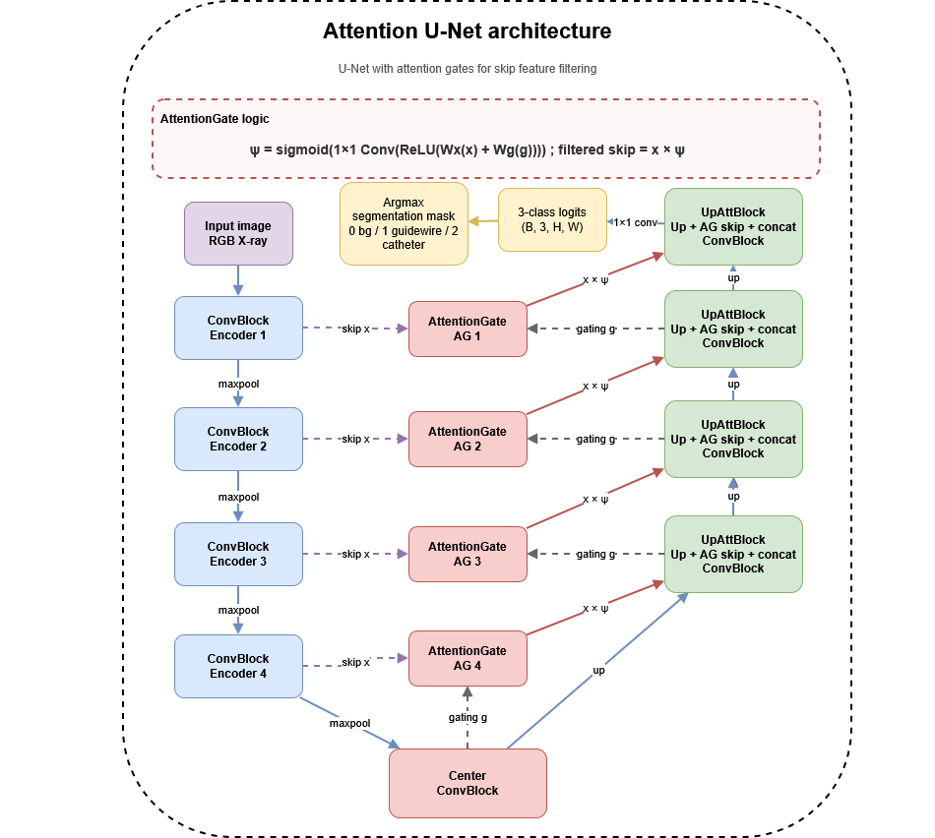
Figure 4. Attention U-net algorithm architecture.

3.4.1 Attention gate
The implementation of attention gate in this program is located in AttentionGate. The design idea of this module is to guide the signal using the high-level semantics provided by the decoder. This module uses high-level semantic information from the decoder as a gating signal to selectively emphasize relevant high-resolution encoder features before feature fusion. In the program, Attention Gate receives two inputs: a gating signal from the decoder, namely g, and the other is the skip feature from the encoder, which is x. Both are mapped to the same number of intermediate channels after 1×1 convolution and Batch Normalisation respectively, then added and activated via ReLU. After that, the results are subjected to a 1×1 convolution and Sigmoid function to generate an attention weight map psi with values ranging from 0 to 1. The final output is x * psi, that is, the encoder features are weighted using attention weights.

Finally, this weight map is element-by-element multiplied with the encoder features to obtain the attention modulated skip feature, which is x * psi. This process assigns higher weights to regions that are semantically consistent with the current decoding stage, and attention weights will be higher, thus preserving and reinforcing relevant responses; However, regions that are not important or irrelevant to the target have lower weights, thus reducing their influence on subsequent decoding.

This is important for the CathAction segmentation dataset because X-ray images contain many background structures, such as bones, vessel textures, instrument shadows, and other linear noise patterns. The guidewire and catheter themselves are very small. If the ordinary skip connection transmits all the shallow features to the decoder, the model may use a lot of irrelevant background information at the same time. The purpose of the Attention gate is to select before feature fusion, so that the model will pay more attention to the regions that may belong to the guidewires and catheters.

3.4.2 Skip feature filtering
Skip feature filtering is another key module of this program. Its essence is to filter and purify the skip connections of traditional U-Net before feature fusion, which is implemented by the UpAttBlock module.

In the Decoder stage, each layer first upsamples the deep features using deconvolution. In case of spatial scale inconsistencies due to pooling or size rounding, features can also be size-aligned using bilinear interpolation. If they don't match, the program adjusts them using F.interpolate(). After that, the encoder features are fed to the attention gating module for filtering, instead of directly concatenating the encoder features with the upsampling results.

The skip features after screening are concatenated with the upsampling results in the channel dimension, and then input into the ConvBlock to complete further fusion and feature reconstruction. The implication of this design is that skip connections are no longer an unconditional information transmission path, but rather a discriminative feature filtering process. Only the really helpful shallow structural information will be retained, thus making the fusion process more focused on the segmentation target itself. This is significantly different from the skip connection of normal U-Net. Ordinary U-Net directly concatenates encoder and decoder features, while Attention U-Net first filters and then concatenates. This step can reduce the interference of irrelevant shallow textures on the final prediction.

3.4.3 Suppress irrelevant background
The suppress irrelevant background mechanism of this procedure is manifested in the explicit inhibitory effect of attention gating on background regions. In traditional segmentation networks, background often occupies most of the area in the image, and its texture, boundary and local contrast changes may interfere with the model. Especially in small target segmentation tasks such as guidewires, catheters or small lesions, the excessive introduction of background information will reduce the sensitivity of the model to key foreground regions.

In this program, background suppression is not done by a separate post-processing module, but is implicitly implemented by AttentionGate at the skip connection level. Previous studies have pointed out that attention gate is able to suppress irrelevant regions and highlight salient features relevant to the task in medical image analysis. Because the attention weight map psi is jointly generated by the current semantic feature g of the decoder and the detailed feature x of the encoder, only those spatial locations that are consistent with the current target semantics are more likely to receive higher weights. Conversely, background regions that are not relevant to the target will be assigned a low response and in turn will be suppressed after element-wise multiplication.

This background suppression strategy is of great significance. Firstly, it reduces the risk of the decoder being misled by the background texture when recovering the resolution. Second, it can improve the model's ability to focus attention when the boundary is fuzzy, the contrast is insufficient, or the target size is small. Third, attention gating does not simply delete features, but performs soft selection according to spatial location, so it is smoother, more stable, and easier to train end-to-end compared with hard threshold clipping [17].

3.5 Attention R2U-Net
As shown in Figure 5, Attention R2U-Net is the most complex model in this study. It combines the repeated residual feature extraction module of the previous R2U-Net with the U-Net feature selection based on attention gates [18]. On the one hand, the RRCNN module is used to enhance the feature extraction capability, and on the other hand, the attention gate is used to filter skipped features before the feature fusion of the decoder and encoder [18].
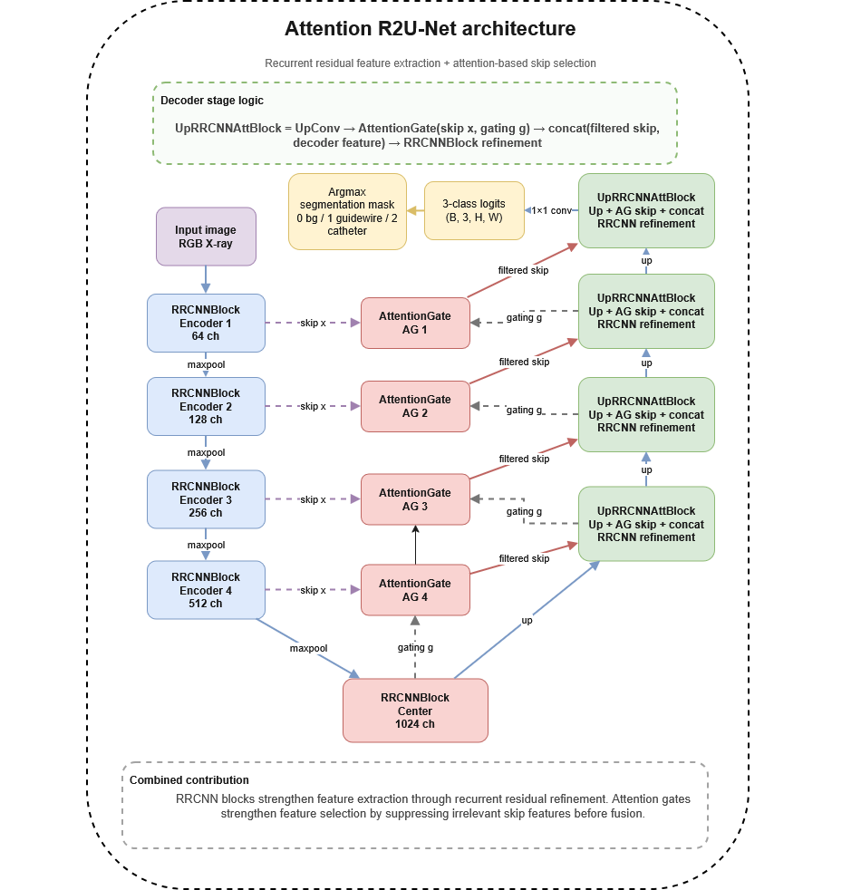
Figure 5. Attention R2U-net algorithm architecture.

3.5.1 R2U-Net + attention gate
In the Attention R2U-Net program, the encoder consists of multiple RRCNNBlocks, including enc1, enc2, enc3, enc4, and center. Each RRCNN block internally contains recurrent convolution and residual addition [6]. The model has the ability to repeatedly extract and accumulate features in the encoding stage [9]. And this program also defines AttentionGate. Its structure is similar to attention gate in attention U-Net. The decoder gating signal and the encoder skip feature are respectively mapped by 1×1 convolution, and then fused to generate the attention weight map, and finally the weighted skip feature is output[8].

This integration is implemented through the UpRRCNNAttBlock module. In this module, the decoder feature is first upsampled by transposed convolution, and then the attention gate is used to filter the skip feature, and then the filtered skip feature is concatenated with the decoder feature. Finally, it is fed into RRCNN block for fusion and further feature extraction. Therefore, each decoder stage in Attention R2U-Net involves four steps: upsampling, attention-based skip-feature filtering, feature concatenation, and recurrent residual refinement [18].

3.5.2 Enhanced feature extraction
The feature extraction of Attention R2U-Net is derived from RRCNN block. The recurrent block in the program will perform multiple convolutional updates on the input features, while the RRCNN block in turn adds the input features to the recurrent output through the residual connection [9]. This structure can theoretically enhance the ability of the model to learn complex local patterns[8][15]. For the guidewires and catheters in the CathAction segmentation task, the model not only needs to identify "whether an instrument is present", but also needs to judge its continuous direction, slender boundary, and local morphology. The repeated feature updates of the RRCNN block may help the model to better capture these details. Compared with ordinary Attention U-Net, each convolution unit of Attention R2U-Net is stronger, because it is not a simple two-layer convolution, but a recurrent residual convolution [9]. This allows the model to perform more sufficient feature refinement at each scale.

3.5.3 Enhanced feature selection
The feature selection of Attention R2U-Net mainly comes from attention gate. In the decoder stage, the model does not directly use the skip feature of the encoder, but first determines which spatial regions are more worth preserving through the attention gate. Subsequently, the filtered skip features are concatenated with the decoder features and enter the RRCNN block.

This is especially important for guidewire and catheter segmentation. The foreground objects in the CathAction segmentation dataset images are usually small and have low contrast, while the background may contain a large number of similar linear structures. If the model directly fuses all skip features, it is easy to mistake the background texture for the target. The Attention gate can reduce the background response before fusion, thus enhancing the relative weight of the foreground region.

3.6 Visualization program
In order to facilitate intuitive testing and result display of the trained segmentation model, this project builds a front-end model visualization interface based on Streamlit (Figure 6). This interface allows users to select different .pt model weight files and upload intravascular interventional procedure X-ray images for segmentation prediction.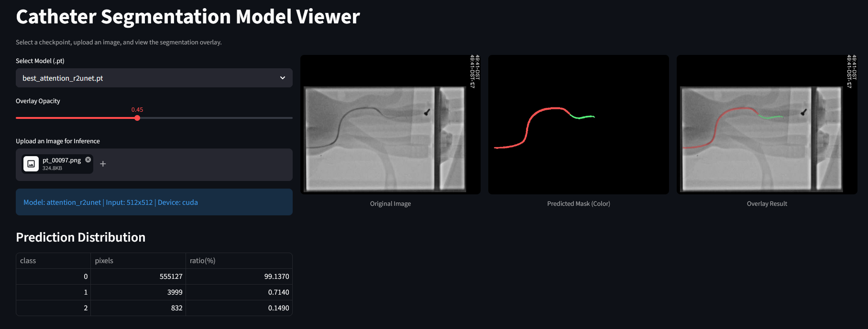
Figure 6. Visual program demonstration.
In this module, the uploaded image is first resized to the required input size of the model and then normalized. Subsequently, the selected model performs forward inference on the image and outputs the prediction of the class to which each pixel belongs. On the page, you can select a pre-trained model for prediction, or you can select an image you want to predict, and the model will then display the prediction result. The logits output by the model are transformed into the final segmentation mask by argmax operation, which is used to distinguish categories such as background, guidewire and catheter. The front-end interface displays the original image, the predicted segmentation mask, and the visual image after superimposing the segmentation results with the original image. At the same time, the interface will also calculate the proportion of pixels of different categories to provide a simple quantitative reference for the segmentation results.

Method
In this experiment, paired X-ray images with pixel-level segmentation masks from the CathAction segmentation dataset (Human silicone phantom) are used as data, and each image corresponds to a mask file in .npy format. Due to limited computational resources, only the labeled data with three-pixel values in the dataset are selected, and the pixel values in the mask include 0, 1, and 2, representing the background, catheter, and guidewire, respectively. Therefore, this task is defined as a three-class image segmentation task. A total of 4,743 samples is used in the experiment, of which 4,043 samples are used for training and the remaining 700 samples were reserved for validation. To control for variation caused by data splitting, the same random seed and the same training-validation partition were used for all four models. Therefore, differences in validation Dice and IoU mainly reflect differences in model architecture and training behaviour under the fixed experimental setting.

Before being fed into the model, all images are screened by a data preprocessing procedure. In order to improve the generalization ability of the model and reduce the risk of overfitting, data augmentation was performed on the training set, including random horizontal flipping, slight affine transformation, and random brightness and contrast adjustments. The geometric enhancement operation is applied to both the image and the corresponding mask to ensure that the pixel-wise labels are consistent with the image content. The validation set does not use random augmentation and is only resized and normalized, thus ensuring the stability and repeatability of the evaluation process.

4.1 Model Configuration
To ensure a fair comparison among the four models, the same training strategy is used for all models, as shown in Table 3. The input image size is fixed to 768 × 768 and the batch size is set to 2. During preliminary training, R2U-Net exceeded the available GPU memory on a GPU with approximately 32 GB of VRAM when the batch size was set higher than 2. Therefore, the batch size was reduced to 2 to ensure that all models could be trained under comparable settings. Therefore, the batch size is adjusted to 2 for the experiment to proceed smoothly. AdamW is used as the optimizer with the initial learning rate set to 1e-3 and weight decay set to 1e-4. The ReduceLROnPlateau learning rate scheduler is used during training to decrease the learning rate when the Dice score on the validation set is no longer improving. Each model saves the weight with the highest Dice score in the validation set during the training process, and the best weight is used as the basis for the final performance comparison.
Table 3. Fixed configurations of the model.
Parameter | Parameter settings
Input size | 768 × 768
Batch size | 2
Epochs | 30
Optimizer | AdamW
Learning rate | 1e-3
Weight decay | 1e-4
Scheduler | ReduceLROnPlateau
Main monitor | validation Dice

4.2 Loss function
Since guidewire and catheter pixels occupy only a small proportion of each image, the task has a significant imbalance between background and object classes, so this experiment uses a hybrid segmentation loss function. The loss function consists of multi-class Dice loss and focal loss. Dice loss is used to directly optimize the overlap between the predicted mask and the ground-truth mask, and focal loss is used to reduce the dominant role of a large number of easy-to-classify background pixels on the loss function, so that the model pays more attention to the difficult to classify foreground regions. The final loss function is defined as:
$$L_{total​}=0.6L_{Dice}+0.4L_{Focal}$$

4.3 Evaluation metrics
The primary evaluation metric was the mean Dice coefficient. For each class, Dice was calculated based on the overlap between the predicted mask and the ground-truth mask. Where $P$denotes the predicted pixel set for a given class, and $G$denotes the corresponding ground-truth pixel set. $∣P∩G∣$represents the number of overlapping pixels between the prediction and the ground truth, while $∣P∣$and $∣G∣$represent the total number of pixels in the predicted and ground-truth regions, respectively.
$$Dⅈcⅇ=\frac{2\left|p∩G\right|}{\left|P\right|+\left|G\right|}$$
The mean Dice score was obtained by averaging the Dice scores across classes. Mean IoU was also reported as a secondary metric. It is used to evaluate the degree of overlap between the predicted mask and the real mask in image segmentation. $\left|P∪G\right|$ represents the union of the predicted and ground-truth regions, including all pixels that belong to either the predicted mask or the ground-truth mask.
$$IoU=\frac{\left|P∩G\right|}{\left|P∪G\right|}$$
Due to the class imbalance, per-class Dice would provide additional insight; however, this study mainly reports overall mDice and mIoU due to the available experimental records. Because the background class occupied most pixels, the foreground mDice, calculated by averaging catheter Dice and guidewire Dice, was used as the main indicator for comparing clinically relevant segmentation performance. The background Dice was reported separately but was not used as the primary ranking criterion.

Experiment

5.1 Experimental Setup
In this experiment, four U-Net variants are trained and compared under fixed datasets and unified experimental Settings, including U-Net, R2U-Net, Attention U-Net and Attention R2U-Net. The task is defined as a three-class pixel-level semantic segmentation task, where the model output channels correspond to the background, guidewire and catheter, respectively. The same data partition was used for all models, with 4,043 images for training and 700 images for validation. The input image size is uniformly adjusted to 768 × 768, and a fixed random seed is used to shuffle the samples to reduce the influence of randomness on the experimental results.

5.2 Evaluation Protocol
After each epoch of training, the model is evaluated on the validation set. For each input image, the model first outputs the logits of the three categories, and then obtains the final prediction mask by argmax operation. The main evaluation metric of the experiment is the mean Dice score of the three categories, while the mean IoU is recorded as an auxiliary index. The highest validation Dice achieved by each model during training is taken as the final performance of that model. Since the background category accounts for a much higher proportion of the image than the guidewire and catheter categories, it is recommended to further report the per-class Dice of background, Guidewire, and catheter in addition to mean Dice, so as to analyze the model's ability to segment small foreground structures more accurately.

5.3 Comparative Experiment Design
The core objective of this experiment is to compare the effect of different U-Net structures on the guidewire/catheter segmentation performance. The U-Net is used as the baseline model to provide a baseline segmentation performance reference. R2U-Net is used to verify whether recurrent residual convolution can enhance the feature extraction ability of the model. Attention U-Net is used to verify whether attention gate can improve the segmentation performance of target regions by screening skip connection features. Attention R2U-Net is used to further analyze whether the combination of recurrent residual block and attention gate can enhance feature extraction and feature selection at the same time, so as to obtain better segmentation performance.

5.4 Results Recording and Presentation
The experimental results are summarized in Table 4, including the best validation Dice for each model, the corresponding mean IoU and the validation loss. Each data is obtained by taking the average of 10 test results to ensure the accuracy of the data (keep four decimal places).
Table 4. Quantitative comparison table.
Model | Best mDice | Best mIoU | Final val_loss
U-Net | 0.6812 | 0.5730 | 0.2012
R2U-Net | 0.6394 | 0.5381 | 0.2403
Attention U-Net | 0.6777 | 0.5710 | 0.2032
Attention R2U-Net | 0.6516 | 0.5472 | 0.2718
In order to further compare the model training process, the validation mDice curve, validation loss curve and training loss curve is plotted to observe whether the model optimization process is stable. The validation Dice curve is used to judge the performance change of the model on unseen data. If a model's training loss continues to decrease but validation Dice is no longer increasing, it may be overfitting.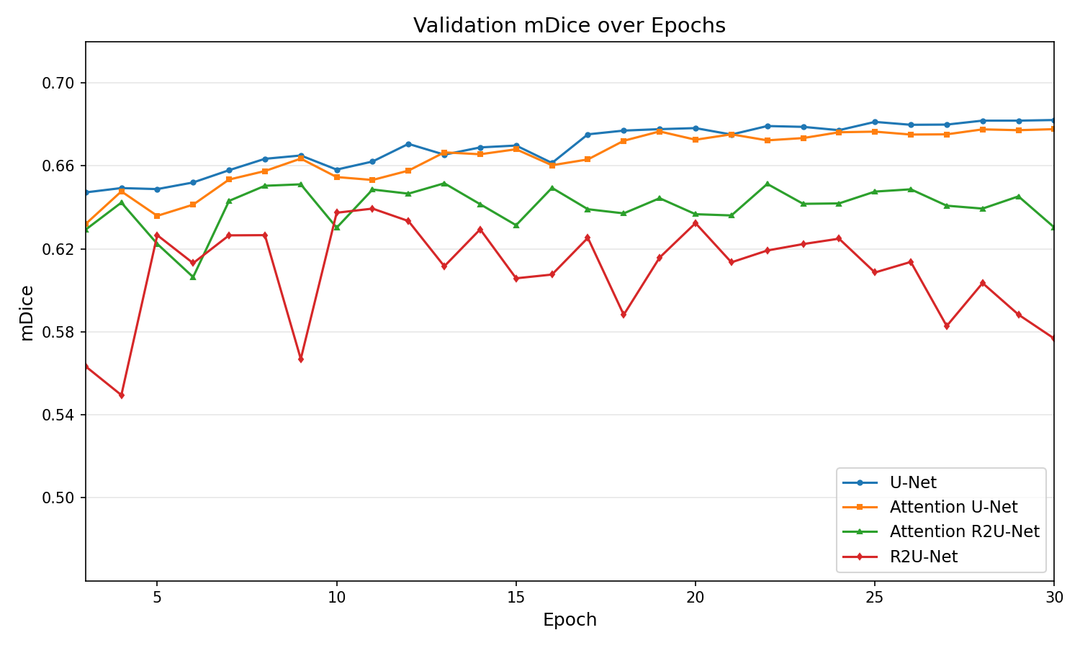
Figure 7. Model validation mDice curve
As shown in Figure 7, U-Net and Attention U-Net achieved the highest and most stable validation mDice scores. U-Net gradually improved during training and remained slightly higher than the other models in the later epochs. Attention U-Net followed a similar trend, suggesting that attention gates helped maintain competitive segmentation performance. In contrast, Attention R2U-Net showed moderate fluctuations and did not achieve consistent improvement. R2U-Net presented the most unstable validation mDice curve, with noticeable fluctuations and a declining trend in the later epochs.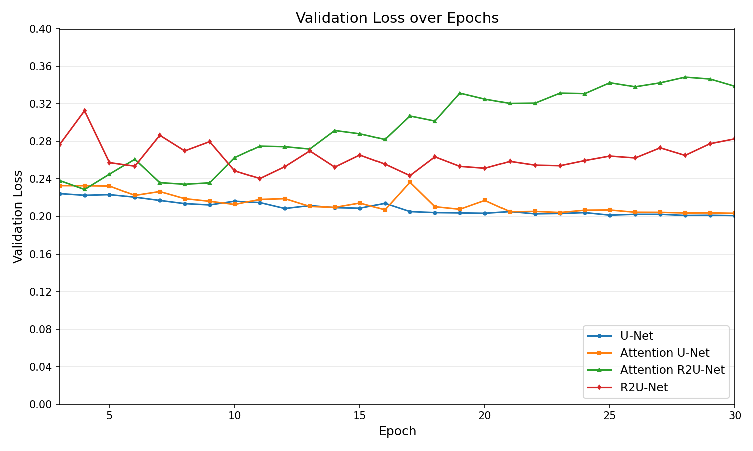
Figure 8. Model validation loss curve
The validation loss curves further support this observation (Figure 8). U-Net and Attention U-Net maintained the lowest validation loss values and gradually converged to approximately 0.20, indicating stable generalization on the validation set. By contrast, Attention R2U-Net showed an increasing validation loss after the middle stage of training, suggesting possible overfitting or reduced generalization ability. R2U-Net also produced higher and more fluctuating validation loss values, which is consistent with its unstable mDice performance.
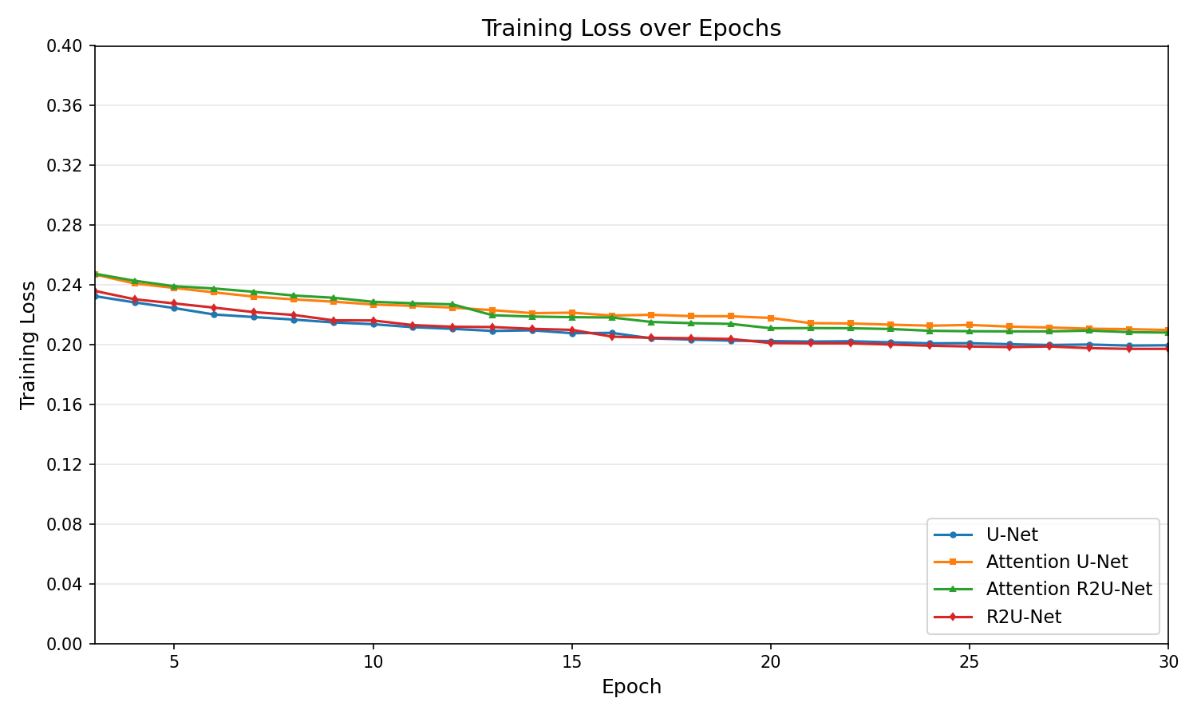
Figure 9. Model training loss curve
As shown in Figure 9, the training losses of all four models show a stable decreasing trend, indicating that they can all learn the features of the training set normally without training failure. The difference in training loss between different models is not large, generally decreasing from about 0.23–0.25 to about 0.20–0.21.

Results Analysis:
Based on human silicone simulated X-ray interventional images in the CathAction dataset, this study conducts comparative experiments on four U-Net series image segmentation models, including U-Net, Attention U-Net, R2U-Net and Attention R2U-Net. The dataset labels are three-class pixel-wise segmentation, and the target categories include background, catheter, and guidewire. In the model program, the input image was uniformly read into RGB format, and the corresponding. npy mask was input into the model as a pixel-level label. Three categories, an input size of 768 × 768, 4,743 total samples, and 4,043 training samples are set in the experimental configuration.

From the overall experimental results, U-Net and Attention U-Net perform the best in the current task. In figure 7, the mDice of U-Net gradually improves from about 0.65 at the initial stage of training, and stabilizes at about 0.68 at the later stage. It shows good convergence and generalization stability. The overall trend of Attention U-Net is very close to that of U-Net, and mDice is also stable in the range of about 0.67-0.68 in the later stage. In contrast, the mDice of Attention R2U-Net mostly maintains between about 0.63-0.65, and although it can reach a relatively high level in some epochs, it does not have a continuous upward trend as a whole. The fluctuation of R2U-Net is the most obvious, and mDice decreases in the later stage, indicating that its validation performance on the current CathAction X-ray images from human silicone vascular phantoms data is not stable。

Under the current implementation and training configuration, the recurrent residual variants did not outperform the ResNet34-based U-Net. The recurrent residual convolutional blocks are used in the R2U-Net program, that is, the feature expression ability is enhanced by repeating convolution and residual connection. Theoretically, this structure helps to capture continuous spatial information and may be suitable for the segmentation of elongated structures such as blood vessels, guidewires and catheters. However, the actual experimental curve shows that the validation mDice of R2U-Net fluctuates greatly, and the validation loss is higher than that of U-Net and Attention U-Net for a long time. One possible explanation is that the recurrent residual blocks increased model capacity and may have made the model more sensitive to background textures under the current training configuration. The reason may be that at low image resolution, the large area of the background weakens the pixels of the target in the image and makes them merge at the pixel level, which cannot be distinguished.

This judgment is further supported by the Validation loss curve in Figure 8. U-Net and Attention U-Net have the lowest validation loss overall and stabilize around 0.20 in the later training period, indicating that these two models not only have higher mDice but also lower validation error. In contrast, the validation loss of R2U-Net is always significantly higher than that of U-Net and Attention U-Net, accompanied by large fluctuations. The validation loss of Attention R2U-Net increases significantly in the middle and late stages, from about 0.24 to about 0.34. Combined with the training loss curve in Figure 9, it can be found that the training loss of Attention R2U-Net still continues to decrease, but the validation loss continues to increase, which is a typical signal of decreasing generalization ability. This means that the model may continue to fit on the training set but fail to improve on the validation set.

The results of Attention U-Net are more interesting. Based on the encoder-decoder structure of U-Net, the model adds an attention gate to the skip connection. In the program, the attention gate uses the decoder feature as the gating signal to weighted filter the skip feature from the encoder, so as to suppress the irrelevant background area and highlight the target area before feature fusion. In the experimental results, the mDice of Attention U-Net is very close to that of U-Net, and the validation loss is also kept low. This indicates that attention gate can maintain good training stability in the current task and does not lead to obvious validation fluctuations as the recurrent structure. Due to the large proportion of background area in CathAction human silicone simulated X-ray images, and the elongated structure of guidewire and catheter with low contrast, it is easy to be confused with the background. Therefore, it can be concluded that attention gate is helpful for the screening mechanism of skip features.

What is clear, though, is that Attention U-Net does not significantly outperform U-Net. It is possible that the U-Net in this experiment already uses ResNet34 as the encoder, so it has a strong ability to extract multi-scale features by itself. And U-Net is built through smp.Unet, using ResNet34 encoder, and recovering spatial resolution through decoder and skip connections. On the current dataset, U-Net has been able to learn the guidewire and catheter regions in human silicone simulated X-ray images well. Although Attention gate helps to filter features, the additional gain brought by it may be partially offset by the feature expressiveness of ResNet34 encoder, so it ends up performing close to U-Net rather than significantly outperforming U-Net.

Synthesizing the three experimental curves, it can be concluded that under the current experimental setup, U-Net and Attention U-Net are the more suitable model choices for this task, while the complex structure of R2U-Net and Attention R2U-Net does not bring the expected performance improvement. U-Net achieves the best balance between validation mDice, validation loss and training stability, it shows that the classical encoder-decoder structure with skip connections has been able to deal with the guidewire and catheter segmentation task in human silicone simulated X-ray images. The performance of Attention U-Net is close to that of U-Net, indicating that attention gate is suitable for this task. skip features may have advantages in suppressing background interference and filtering. In contrast, the recurrent residual structure of R2U-Net and Attention R2U-Net increases the model complexity, but does not translate into better validation performance on the current dataset, and instead exhibits more obvious fluctuations and potential overfitting problems.

Project Ethics
This project involves data and model training that do not involve any human data privacy, and guarantees that
no data privacy regulations will be violated throughout the research process. The training datasets are all publicly
available and contain no human involvement or human experimentation. Ethical requirements that meet university requirements.

Conclusion & Future Work
In summary, the main conclusions of this study are as follows: for the guidewire and catheter segmentation task in CathAction human silicone simulated X-ray images, the U-Net variants with relatively simple structure have advantages. The introduction of complex recurrent structures requires more careful tuning in combination with data scale, target morphology, regularization strategy, and training parameters. For further optimization, it is recommended to prioritize improvements around U-Net and Attention U-Net, such as adding more refined per-class Dice evaluation, foreground class weighting, boundary loss function, or post-processing methods, rather than simply increasing the depth and structural complexity of the network.

But at the same time, compared to the difference between U-net and Attention U-Net, what is more noteworthy is the difference between Attention U-Net and Attention R2U-Net. In the previous experimental results, it has been concluded that using recurrent residual convolutional blocks does not perform well on this dataset. However, the Attention gate mechanism makes up for this part of the defects, so if we can better integrate ResNet34 and attention gate, the experimental results may have a new breakthrough.

Based on the current results, future work should focus on exploring architectures that can improve global feature modelling while maintaining stable training performance. Although U-Net and Attention U-Net achieved the most stable results in this experiment, their convolution-based structures may still be limited in capturing long-range dependencies across the X-ray image. Therefore, Transformer-based segmentation networks, such as TransUNet and Swin-UNet, could be tested in future experiments. These models use self-attention mechanisms to model global spatial relationships and may be more effective for identifying long and thin structures. In addition, other advanced segmentation models, including UNet++, DeepLabv3+, SegFormer and CNN-Transformer hybrid networks, could be evaluated on the same CathAction phantom X-ray dataset. Future work should also report per-class Dice and IoU scores to better assess the segmentation performance for guidewire and catheter separately.

Furthermore, future research could focus on data preprocessing. Adding attention mechanisms to data preprocessing, such as using simple visual models to identify targets, delineate approximate target regions, and reduce the background proportion in the image, could prevent the target from becoming excessively blurry when inputting large-resolution datasets into the training script due to the model's fixed recognition resolution channels.

In conclusion, this study demonstrates that U-Net and Attention U-Net achieved more stable and competitive performance than the recurrent variants on the CathAction phantom X-ray segmentation task. Although more complex architectures may provide stronger theoretical feature representation, they do not necessarily lead to better validation performance under the current dataset and training configuration. Therefore, future work should further explore Transformer-based and hybrid segmentation networks while improving model generalisation on both phantom and real clinical X-ray images.

BCS Criteria & Self-Reflection

9.1 An ability to apply practical and analytical skills gained during the degree programme
- Use the Artificial Intelligence module (COMP 219) to build the basic code architecture.
- Use the database module (COMP 207) to manage model datasets.
- Use the project development framework learned from COMP 208 to build code for large-scale projects.
- Proficiently use knowledge of COMP 202 and COMP 281 to write code and set up compilation environments.

9.2 Innovation and/or creativity
- The project shows creativity by comparing several U-Net variants and by building a complete segmentation pipeline that includes preprocessing, model training, evaluation, and a Streamlit-based visualisation interface.
- The development process will take into account engineering deployment issues, ensuring model can still run on relatively low-performance computing devices.

9.3 Synthesis of information, ideas and practices to provide a quality solution together with an evaluation of that solution.
- During the development of this project, I progressed steadily by identifying, exploring, solving, and summarising problems.
- I searched relevant literature and open-source resources, listed the goals to be achieved, and then combined good ideas from various parties with existing practices to select the most feasible solution.
- I combined thinking and doing, using evidence to prove the feasibility of the solution.

9.4 It meets practical needs in a broad real-world context
- This conclusion of project can be deployed on embedded devices in medical institutions to assist doctors in the surgical process and help them avoid the risk of harm to patients.
- In the long run, it can serve as part of a robotic automated surgery system, providing solutions for potentially more efficient treatment options in the future.

9.5 An ability to self-manage a significant piece of work
During this project, I demonstrated the ability to self-manage a significant piece of work by independently planning, organising, implementing and evaluating a complete medical image segmentation study. The project required working with the CathAction dataset and compare the segmentation performance of four U-Net-based models, including U-Net, R2U-Net, Attention U-Net and Attention R2U-Net. Because the task involved multiple stages, I needed to manage the workflow carefully. From dataset preparation and preprocessing to model training and result analysis.

To begin with, I broke my work down into several manageable components. First, I examined the dataset structure, including the X-ray images and the corresponding ground-truth mask files. And then I designed a consistent experimental pipeline, so that all four models could be trained under the same conditions. Just like the same training and validation split, image resolution, batch size, optimiser, learning rate scheduler and evaluation metrics.

I also needed to address technical challenges encountered during deep learning model training. For example, I needed to adjust the mask format, confirm the number of segmentation categories, refine the image preprocessing workflow, and monitor the Dice coefficients and IoU performance in the training logs to ensure model stability. When replacing the baseline U-Net with R2U-Net, Attention U-Net, and Attention R2U-Net, I reconstructed the model framework as much as possible, experimenting with my own designed R2U-Net and Attention U-Net models. This allowed me to thoroughly understand the model architecture and grasp the abstract essence of segmentation.

All in all, I self-managed the writing process of the project. I organised the report into clear sections, including the introduction, literature background, methodology, experiment design and results. I also reflected on how to explain the models in an academic way, especially the roles of encoder-decoder structure, skip connections, recurrent convolution, residual learning and attention gates. Overall, this project helped me develop stronger independence in handling a large-scale technical task, sometime in planning experiments, solving implementation problems and presenting the work in a structured academic format.

9.6 Critical self-evaluation of the process
Looking back at the process, I think there were also several limitations that should be critically evaluated. Firstly, there are shortcomings in terms of model computing power, but the cost of using a high-performance computing platform is too high, which I cannot afford. Secondly, the CathAction dataset contains images with varying resolutions, and no fine-tuning was performed in the data processing. A uniform resolution framework was simply used to roughly adjust the resolution. This causes some large-format objects to become abnormally blurry after adjustment, resulting in a decline in training performance.

Another limitation was related to model comparison. Although I compared U-Net, R2U-Net, Attention U-Net and Attention R2U-Net, the performance differences may not be caused only by the architectural design. Factors such as hyperparameter settings, training duration, data augmentation, random seed and class imbalance could also affect the results. Therefore, while the comparison can show useful trends, it should not be interpreted as an absolute ranking of these architectures in all medical segmentation tasks. I also realized that due to limited computing power, I was unable to fully realize the model's training potential. To ensure proper training, I implemented measures such as using a portion of the dataset and reducing the batch size. Therefore, the reference value of this study remains to be explored.

Overall, this project improved my understanding of both deep learning implementation and scientific evaluation. I learned that a model with a more complex architecture does not automatically guarantee better performance. In medical image segmentation, the final result depends on the interaction between dataset characteristics, preprocessing, model design and training strategy. Through this process, I became more aware of the importance of fair experimental design, careful result interpretation and honest discussion of limitations.

References:
[1] P. Ambrosini, D. Ruijters, W. J. Niessen, A. Moelker, and T. van Walsum, ‘Fully Automatic and Real-Time Catheter Segmentation in X-Ray Fluoroscopy’, in Medical Image Computing and Computer-Assisted Intervention − MICCAI 2017, M. Descoteaux, L. Maier-Hein, A. Franz, P. Jannin, D. L. Collins, and S. Duchesne, Eds, Cham: Springer International Publishing, 2017, pp. 577–585. doi: 10.1007/978-3-319-66185-8_65.
[2] A. K. Thukkani and S. Kinlay, ‘Endovascular Intervention for Peripheral Artery Disease’, Circulation Research, vol. 116, no. 9, pp. 1599–1613, Apr. 2015, doi: 10.1161/CIRCRESAHA.116.303503.
[3] CathAction, ‘CathAction Dataset’, CathAction. Accessed: May 02, 2026. [Online]. Available: https://airvlab.github.io//cathaction/
[4] R. Wang, T. Lei, R. Cui, B. Zhang, H. Meng, and A. K. Nandi, ‘Medical image segmentation using deep learning: A survey’, IET Image Processing, vol. 16, no. 5, pp. 1243–1267, 2022, doi: 10.1049/ipr2.12419.
[5] J. Eves, A. Sudarsanam, J. Shalhoub, and D. Amiras, ‘Augmented Reality in Vascular and Endovascular Surgery: Scoping Review’, JMIR Serious Games, vol. 10, no. 3, p. e34501, Sep. 2022, doi: 10.2196/34501.
[6] O. Ronneberger, P. Fischer, and T. Brox, ‘U-Net: Convolutional Networks for Biomedical Image Segmentation’, in Medical Image Computing and Computer-Assisted Intervention – MICCAI 2015, N. Navab, J. Hornegger, W. M. Wells, and A. F. Frangi, Eds, Cham: Springer International Publishing, 2015, pp. 234–241. doi: 10.1007/978-3-319-24574-4_28.
[7] S. Saluja, M. C. Trivedi, and A. K. Dubey, ‘U-Net Variants for Brain Tumor Segmentation: Performance and Limitations’, in 2023 International Conference on Computational Intelligence, Communication Technology and Networking (CICTN), Apr. 2023, pp. 612–616. doi: 10.1109/CICTN57981.2023.10141477.
[8] O. Oktay et al., ‘Attention U-Net: Learning Where to Look for the Pancreas’, May 20, 2018, arXiv: arXiv:1804.03999. doi: 10.48550/arXiv.1804.03999.
[9] M. Z. Alom, M. Hasan, C. Yakopcic, T. M. Taha, and V. K. Asari, ‘Recurrent Residual Convolutional Neural Network based on U-Net (R2U-Net) for Medical Image Segmentation’, May 29, 2018, arXiv: arXiv:1802.06955. doi: 10.48550/arXiv.1802.06955.
[10] C. Guo, M. Szemenyei, Y. Yi, W. Wang, B. Chen, and C. Fan, ‘SA-UNet: Spatial Attention U-Net for Retinal Vessel Segmentation’, in 2020 25th International Conference on Pattern Recognition (ICPR), Jan. 2021, pp. 1236–1242. doi: 10.1109/ICPR48806.2021.9413346.
[11] M. Z. Alom, C. Yakopcic, T. M. Taha, and V. K. Asari, ‘Nuclei Segmentation with Recurrent Residual Convolutional Neural Networks based U-Net (R2U-Net)’, in NAECON 2018 - IEEE National Aerospace and Electronics Conference, Jul. 2018, pp. 228–233. doi: 10.1109/NAECON.2018.8556686.
[12] ‘CathAction: A Benchmark for Endovascular Intervention Understanding’. Accessed: May 04, 2026. [Online]. Available: https://arxiv.org/html/2408.13126v1
[13] ‘Segmentation Models — Segmentation Models documentation’. Accessed: May 04, 2026. [Online]. Available: https://smp.readthedocs.io/en/latest/models.html
[14] K. He, X. Zhang, S. Ren, and J. Sun, ‘Deep Residual Learning for Image Recognition’, in 2016 IEEE Conference on Computer Vision and Pattern Recognition (CVPR), Jun. 2016, pp. 770–778. doi: 10.1109/CVPR.2016.90.
[15] M. Raghu, C. Zhang, J. Kleinberg, and S. Bengio, ‘Transfusion: Understanding Transfer Learning for Medical Imaging’, in Advances in Neural Information Processing Systems, Curran Associates, Inc., 2019. Accessed: May 04, 2026. [Online]. Available: https://proceedings.neurips.cc/paper_files/paper/2019/hash/eb1e78328c46506b46a4ac4a1e378b91-Abstract.html
[16] M. Liang and X. Hu, ‘Recurrent convolutional neural network for object recognition’, in 2015 IEEE Conference on Computer Vision and Pattern Recognition (CVPR), Jun. 2015, pp. 3367–3375. doi: 10.1109/CVPR.2015.7298958.
[17] J. Schlemper et al., ‘Attention gated networks: Learning to leverage salient regions in medical images’, Medical Image Analysis, vol. 53, pp. 197–207, Apr. 2019, doi: 10.1016/j.media.2019.01.012.
[18] Q. Zuo, S. Chen, and Z. Wang, ‘R2AU-Net: Attention Recurrent Residual Convolutional Neural Network for Multimodal Medical Image Segmentation’, Security and Communication Networks, vol. 2021, no. 1, p. 6625688, 2021, doi: 10.1155/2021/6625688.

